“[Insert title of assignment]”

“[Insert Name & Surname]”

Report presented in partial fulfilment
of the requirements for the degree of
BComHons (“[insert name of degree e.g. Mathematical Statistics]”)
at the University of Stellenbosch

Supervisor: “[Insert title, name and surname]”

Degree of confidentiality: | “[Insert month and year of final submission]”
Plagiarism Declaration
- Plagiarism is the use of ideas, material and other intellectual property of another’s work and to present it as my own.
- I agree that plagiarism is a punishable offence because it constitutes theft.
- I also understand that direct translations are plagiarism.
- Accordingly, all quotations and contributions from any source whatsoever (including the internet) have been cited fully. I understand that the reproduction of text without quotation marks (even when the source is cited) is plagiarism.
I declare that the work contained in this assignment, except otherwise stated, is my original work. I have also not previously (in its entirety or in part) submitted it for grading in this module/assignment or another module/assignment.
Student number | Initials and surname
 | Signature
  Date

Student number | Initials and surname
 | Signature
  Date
Copyright © 2026 Stellenbosch University
All rights reserved
Declaration on the Use of Artificial Intelligence Tools
- I have discussed the use (or non-use) of GenAI tools with my supervisor, and we have agreed on appropriate boundaries.
- I have verified and take responsibility for all information, arguments, data, and conclusions in this assignment/thesis. I am accountable for the integrity of the work.
- I confirm that AI tools were not used in ways that breach SU’s plagiarism, confidentiality, or research integrity policies.
- No data were generated by GenAI unless this was a deliberate and declared part of the research methodology.
- I am willing to be questioned in an oral examination on the scope, purpose, and verification of any GenAI use in this work.
Institutional Acknowledgement
This declaration aligns with Stellenbosch University’s Position Statement on the ethical use of AI in Research and Teaching-Learning-Assessment, the Draft interim SU guidelines on allowable AI use and academic integrity in assessment, and draws on international best practices.
Student number | Initials and surname
 | Signature
  Date

Student number | Initials and surname
 | Signature
  Date

Acknowledgements
The author acknowledges institutions and people that significantly contributed to the research in this section.
For example:
The Department of Statistics and Actuarial Science (the Department) wishes to acknowledge the University of Stellenbosch Business School (USB) for generously making available their research report template and guidelines. The USB template and guidelines have been adapted for the purposes of the Department.
Abstract
“[Insert an abstract of not more than 500 words here]”
Key words:
Technical guidelines; Chapter outline; Examples
Table of contents
Plagiarism Declaration ii
Acknowledgements iii
Abstract iv
List of Tables vii
List of Figures ix
List of Appendices x
List of abbreviations and/or acronyms xi
CHAPTER 1 INTRODUCTION 1
1.1 Introduction 1
1.2 Problem statement 1
1.3 Clarification of key concepts 1
1.3.1 Report 1
1.3.2 Supervisor 1
1.3.3 Editor 2
1.3.4 The use of styles in MS Word 2
1.4 research Question(s) 3
1.5 importance / benefits of the study 3
1.6 RESEARCH DESIGN AND METHODOLOGY 3
1.6.1 Sampling 3
1.6.2 Questionnaire design and data collection 3
1.6.3 Data analysis 3
1.7 CHAPTER OUTLINE 3
1.8 NATURE AND FORM OF RESULTS 4
1.9 CONCLUSION 4
CHAPTER 2 LITERATURE REVIEW 5
2.1 Introduction 5
2.2 General Page layout 5
2.3 Headings and lists 5
2.3.1 Numbering of headings 6
2.4 Formatting of tables and figures 6
2.4.1 Tables 6
Source: Thompson, Strickland and Gamble, 2007: 20. 7
2.4.2 Figures 8
Figure 2.1 Technical layout of the report 8
2.4.3 Numbering of tables and figures 9
Source: Thompson, Strickland and Gamble, 2007: 20. 9
2.5 Cross-referencing 9
2.6 Summary 9
CHAPTER 3 RESEARCH METHODOLOGY 11
3.1 Introduction 11
3.2 The population and sample 11
3.3 The questionnaire design 11
3.4 Data Collection 11
3.5 Data Analysis 11
CHAPTER 4 FINDINGS 12
4.1 introduction 12
4.2 the profile of respondents 12
4.2.1 FORMULAS 12
CHAPTER 5 SUMMARY, CONCLUSION AND RECOMMENDATIONS 13
5.1 introduction 13
5.2 Summary of main findings 13
5.3 Policy implications 13
5.3.1 Globally 13
5.3.2 South Africa 13
5.4 Priorities going forward 13
5.5 Recommendations 13
5.6 Further research 13
REFERENCES 14
APPENDIX A: QUESTIONNAIRE 15
APPENDIX B: USB STYLE SHEETS 16

List of Tables
Table 2.1 Definitions of concepts 6
Table 2.2 Numbering of tables 8
Table 2.3 Tables containing percentages 8

List of Figures
Figure 2.1 Technical layout of the report 7

List of Appendices
APPENDIX A QUESTIONNAIRE
APPENDIX B USB STYLE SHEETS
List of abbreviations and/or acronyms
USB University of Stellenbosch Business School

INTRODUCTION
- Introduction
In our experience, many students experience difficulties with the formatting of their reports. It will save you time if your document is in the correct format from the beginning. This template is designed to assist you in writing a report in the correct format as required by the Department of Statistics and Actuarial Science (the Department). The document is written in the format required by the Department and aims to give some practical advice along the way. The headings in this, the first chapter, give the student an indication of the structure of a typical first chapter. Students can adapt these according to their reports, whether it is qualitative or quantitative and whether hypotheses are included.
Note that the table of contents does not refer to itself, i.e. it is not an item within the table of contents. The tabs running up to the page numbers do not have any leader characters, i.e. dots.

Problem statement
This section states the problem that you are exploring. You should, in this section also state the research question clearly. The difference between the research problem and research question is that the problem is broader, while the research question represents the “one question that you will answer at the end of your report”. The research question therefore is specific, concise, and clear. It is possible to expand the research question by using sub-questions.

Clarification of key concepts
In this section you need to highlight the main concepts that are being used in your assignment. For example, in this particular document the concepts of “report”, “supervisor” etc. are being discussed.

Report
The report is the product of the research assignment component of the US honours degree.

Supervisor
The supervisor is the person who will guide you in your research. This person is not your language editor or a research assistant.

Editor
An editor is a person who can help you to make sure your document is grammatically and technically correct. Some editors can also translate documents for you or will comment on chapter or paragraph structure. You can also contact the University of Stellenbosch’s Language Centre (http://www0.sun.ac.za/taalsentrum/student-home.html) for assistance in writing your report. They provide services from general writing skills through to editing services, the latter service for a fee.

The use of styles in MS Word
Most of the formatting of this document was done with ‘styles’ in MS Word. Figure 2.1 shows most of the styles as it would appear in Microsoft Word for Office 365 in Windows. We will refer to some of these styles throughout the document. For instance, the text you are reading is formatted as ‘normal’, while the heading below Figure 2.1 is formatted as ‘USB Figure heading’. The body of the report is typed in ‘normal’ which is justified Cambria 11 point with a built-in space after each paragraph.
Refer to Appendix B for a complete list of styles to be used.
If you only obtain this template after you have typed the report, the template can be used to format paint the report into the correct styles of formatting using this tool: 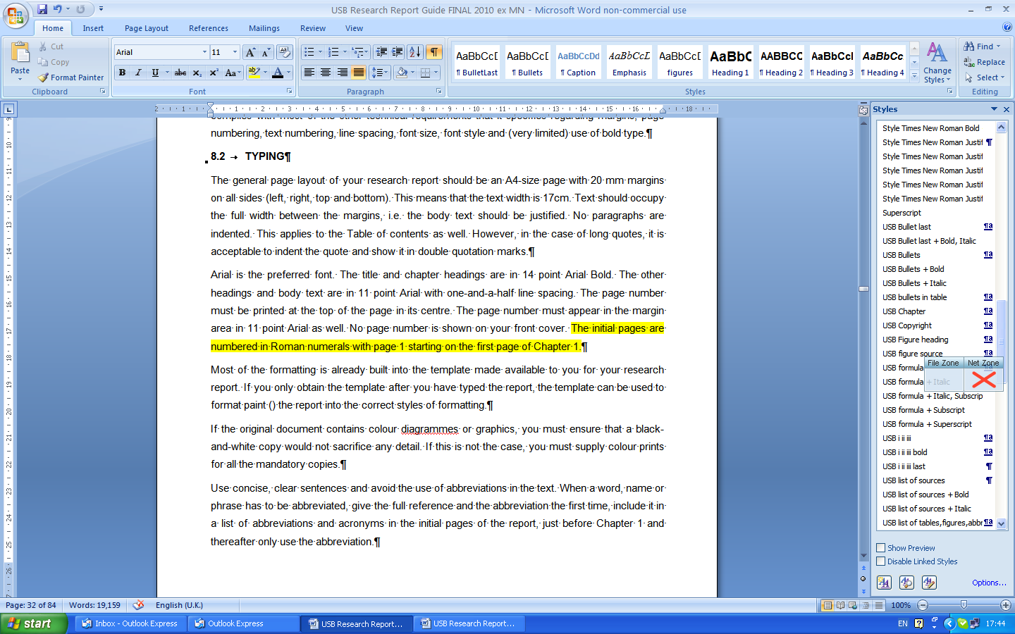
Use the styles to format text in the correct format. This will make your life a great deal easier and assure that you comply with the Department’s report guidelines.
The ‘Style inspector’ can be used to determine which style is applied within the template document. The ‘Style inspector’ can be obtained by extending the ‘Styles’ options and selection the ‘Style Inspector’:
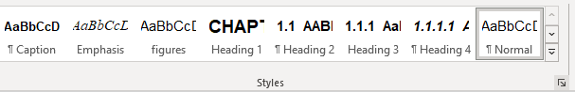
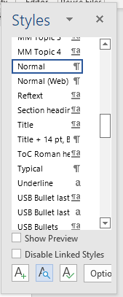

research Question(s)

importance / benefits of the study

RESEARCH DESIGN AND METHODOLOGY

Sampling

Questionnaire design and data collection

Data analysis
- Data analysis 1
- Data analysis 2
Data analysis 3

CHAPTER OUTLINE
This section provides the reader with an overview of what to expect. Some students make use of a diagram to do this with great effect.
Chapter Two provides a literature review ...
Chapter Three outlines the specific methodology employed in the study.
Chapter Four provides a discussion of the findings in relation to previous research.
Chapter Five gives a summary of the findings, a conclusion, as well as limitations of this study. It also offers some recommendations for future research.

NATURE AND FORM OF RESULTS

CONCLUSION

LITERATURE REVIEW

Introduction
This chapter of the report contains an outline of the literature that is relevant to research question.
In this template, the format of the report will be discussed in some detail. More information is available in the Research Assignment Guide.

General Page layout
The general page layout of your report should be an A4-size page with 25 mm margin on the left and 20mm margin on all other sides (top, right and bottom). This means that the text width is 16.5 cm. Text should occupy the full width between the margins, i.e. the body text should be justified. Arial is the preferred font. The title and chapter headings are in 14 point Cambria Bold. The other headings and body text are in 11 point Cambria.

Headings and lists
New headings should not start at the bottom of a page with less than two lines. Rather insert a page break and start the heading on a new page. In general, the best way to force a page break is to press [Ctrl-Enter] or click Insert Page Break.
All chapters in a report should have an introduction and summary. Note that headings like the one above should be in upper case. Leave no space under the heading, as the formatting already provides for a space.
The headings in this document are formatted in accordance with the Department’s guidelines. Use the tool to paint headings of the same level or select the same type of heading from the list of Styles. Here are the names of the headings:
- HEADING 1, first level heading. (this is the Chapter heading and used for headings on the initial Roman number pages. It should be in the centre with a ‘soft enter’ (Shift-Enter) to separate the words “CHAPTER X from the heading. It is in 14 point Cambria);
- HEADING 2, second level heading (left aligned, bold, upper case, 1.1 heading);
- Heading 3, third level heading (left aligned, bold, upper and lower case, 1.1.1 heading); and
Heading 4, fourth level heading (left aligned, bold, italic, upper and lower case, 1.1.1.1 heading).
Note that you should refrain from using too many capitals in a heading. Rather write ‘Demographic profile of respondents’ and not ‘Demographic Profile of Respondents’. There are no spaces (enters) before or after headings. There are ‘automatic spaces’ built into the template.
Note that the Bullet style is used where a list of a few items is given as above and where each bullet is only a few words or a line long. All bullets should start with a capital letter and end with a semi-colon or a full-stop. There is also a ‘Bullet last’ style. This style has a slightly bigger space below the bullet.
For longer lists especially those referred to as a numbered list, use the style called ‘USB list to follow’ for this line and then the following style called ‘USB i ii iii’ for the numbered items:
- This is the first item.
- This is the second item.
This is the third item.

Numbering of headings
By applying the headings, the numbering will continue automatically for sections in a given chapter. The numbering relates directly to the headings as explained in Section 2.3.
The following keyboard short cuts can be used:
- First level heading, Chapter X: [Ctrl-Alt-1]|
- Second level heading, X.X: [Ctrl-Alt-2]|
- Third level heading, X.X.X: [Ctrl-Alt-3]

Formatting of tables and figures

Tables
Table 2.1 is an example of what a table should look like in a Department report. Tables should be centred and preferably 16.5 cm wide, as your text width is also 16.5 cm. Also, note that there is a style designed specifically for text in tables. You may choose to centre some text in tables, but start out with USB Table text and then change the alignment ‘manually’. The table text is slightly smaller at 10 point Cambria and has some ‘breathing space’ of three points around it. Each column should have a heading in bold. The headings on the left-hand side should be left aligned. The other headings/columns can be either left aligned or centred depending on their content. If the column contains text, as in Table 2.1, it will be left aligned. If numerical data is given, the heading will be centred and the numbers within the column will be right aligned with the decimal points lining up. Refer to example Table 2.2. Also, show only a relevant number of decimal places (not 534.785623, but 534.8 – if you show a large number of decimal places you infer accuracy!). Be consistent and stay with one or two decimal places throughout.
Where the information is too little to put into a table that is 17 cm wide, make the table 8 cm wide or whatever works for the information, but try to be consistent in the sizes so that your report has only one or two sizes and all the tables or figures are not different sizes.
Tables are always blocked. Figures also seem neater when blocked. Consistency is key.
Note that the reference should include a page number as you are referring to a table on a specific page in the source. The style used for the reference is called ‘USB Table source’ and ‘USB figure source’. This is always centred so that it works with any size table or figure.
Table 2.1 Definitions of concepts
Concepts | Definition
Table text | Table text = 10 pt and not justified, but left aligned to avoid text stretching over the width of the table cell
Formatting | Please format all the text in the table. Under “paragraph formatting” ensure that the “keep to next” box have been ticked to avoid the table splitting over pages. (Using the “USB Table text” style means that these problems are automatically avoided.) The last row in the table must pull the source info with it (The heading is already pre-formatted to stick to the table)
Number of lines | If your table runs over two pages, repeat the heading with (continued) in brackets and repeat the headings of the columns

Source: Thompson, Strickland and Gamble, 2007: 20.

Figures
Figures are numbered and the title is given below the figure. When referring to a specific table or figure, write the word with a capital letter, as you would for Figure 2.1 below.
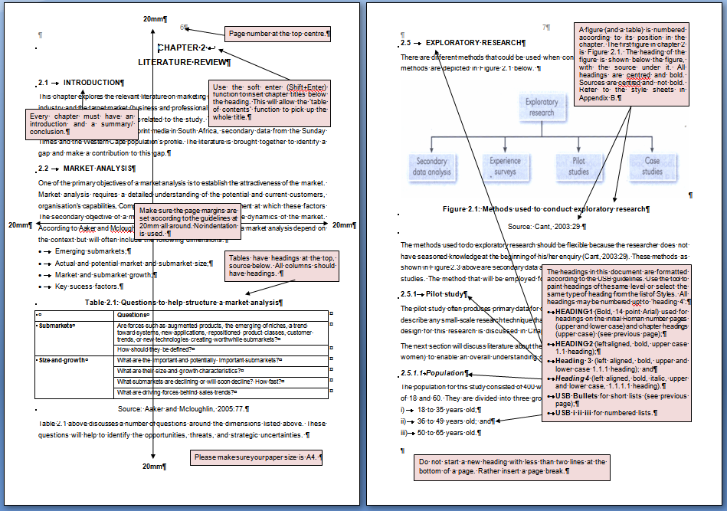

Figure 2.1 Technical layout of the report
Source: USB, 2008: 20.

Numbering of tables and figures
The number of a table reflects its position in the document. Table 2.2 below, for instance, indicates that this is the second table in CHAPTER 2. This table is 8 cm wide and shows the decimals lining up in the column on the right-hand side which is formatted in USB Table text decimals. The cells were formatted using Paragraph, format Tabs, Decimal so that the decimal points line up automatically.
Table 2.2 Numbering of tables
Month | Sales | Growth
January | 2 488 | 1.45
February | 1 009 | 12.50

Table 2.3 Tables containing percentages
Month | 2007 | 2008 | Improvement
June | 14 | 20 | 43%
July | 12 | 27 | 125%
August | 13 | 21 | 62%
September | 15 | 20 | 33%
Total | 54 | 88 | 63%

Source: Thompson, Strickland and Gamble, 2007: 20.

Cross-referencing
Linking sections / tables / figures throughout the dissertation in your discussions will improve the overall flow of the document. Use the ‘Cross-reference’ option in the ‘References’ tab to include cross-reference automatically. This will ensure that cross references are updated as section numbers might change during the writing process:
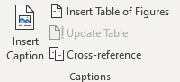

Summary
Every chapter should have a summary (with possibly the exception of your introductory chapter and your last chapter). This section tells the reader what the main messages are and what you would like the reader to take forward. It also provides you with an opportunity to link with your next chapter.

RESEARCH METHODOLOGY

Introduction
The introduction to this chapter could start with something like “This research made use of a standardised questionnaire.”
This is an example of using actual quotes and should be placed between quotation marks “ “ whereas specific terms, such as the styles used ‘normal’ vs. ‘USB Chapter’ are given between single quotation marks as they refer to terms and not actual quotes.

The population and sample

The questionnaire design

Data Collection

Data Analysis

FINDINGS

introduction

the profile of respondents
The above may or may not be a heading in your report. Here you can discuss the demographics. (This line is typed in USB list to follow.) The respondents included people from the following industries:
- Agriculture;
- Mining;
- Public service; and
Military.
The respondents ...

FORMULAS
Using the balance sheet identity: $A= L + E$
$$A=L+E$$ | (4.1)
Where $A$ is total assets, $L$ is total liabilities and $E$ is total equity.
Note that his is the first formula (the number following the full stop) in CHAPTER 4 (i.e. the formula number is also dependent on the chapter).
To assist with the spacing of an equation and the equation number, it is useful to add a two-column table into your document and then hide the borders. The equation can then be inserted, using Word’s equation editor (refer to the “insert” tab), in the first column and the equation number in the second column.

SUMMARY, CONCLUSION AND RECOMMENDATIONS

introduction
The conclusion chapter provides the reader with the ‘so what’ and ‘now what’ section. Do not neglect this part of your report. In essence this is the part where you show how much you have contributed to the body of knowledge of your field. This is also the chapter that will be read by most people who scan your report.

Summary of main findings

Policy implications

Globally

South Africa

South Africa as a country

Western Cape
The above is an example of a Heading 4 in the document. The Department guidelines limit you to four numbers in the heading.
When you refer to numbers smaller than ten, rather use the words. If you refer to larger numbers, you can use 25, 33 and 82. Also note that the Department prefers the use of the words per cent to the use of the % symbol when used in body text. If you refer to numbers in brackets or in figures, the % symbol is acceptable. Refer to Table 2.3.

Priorities going forward

Recommendations

Further research

REFERENCES
List your sources here in alphabetical order (not subdivided in different categories). The references (from Andersen below) are formatted in 16 pt spacing which is between single and one-and-a-half spacing, with 12 pt space after to define each source. It is left aligned to keep electronic references from stretching too wide across the width of the page but the second line is left “hanging” at 0.63cm. Refer to the style sheet named ‘USB References’. Start with formatting all your resources in this style and then format the words required in italics or bold according to the examples in the guide. Note that where you have two references in the same year, use a and b to distinguish between the two
The research assignment guide provides more information about each type of document, such as books, journal articles and electronic references.
When referring to websites it is very important to verify the quality of the information referred to. Anybody can start a website and post any idea on that site. That does not make it a good source. Hence the reputation of the author or owner of the website is important in determining the quality of the information. Preferably articles referred to should have an author, and the article should have a date when it was published. If the author cannot be identified nor can a date of publication be identified, it could well be an indication of the lack of quality of the source. If the document referred to does not have a date, the copyright date of the website can be used in lieu of the article date. If the author of the article is not identified, the owner of the website (company or association, for instance “The Economist”) should be identified as the author or owner and referenced accordingly.
Always reference the author and date of publication where possible.
If no date is available for the publication, rather say “no date”, but still show the date you accessed the information in your references.
It is advised to make use of a reference management system, such as Mendeley. Refer to the Introduction to Mendeley slides on SUNLearn.

APPENDIX A:
QUESTIONNAIRE
This is how an appendix is given. It has a heading just like a chapter and title describing the appendix. Whenever it is referred to in the main section of the report, it is referred to as Appendix A.
This might include your questionnaire, feedback from respondents, maps, etc.
If you have any figures or tables here, number the according to the appendix, e.g. Figure A.1 would be the first figure in Appendix A.
APPENDIX B:
USB STYLE SHEETS
Name of style sheet | Where the style sheet should be used
Heading 1 | Roman page headings and chapter headings
Heading 2 | 1.1 HEADINGS
Heading 3 | 1.1.1 Headings
Heading 4 | 1.1.1.1 Headings
Normal | Body text in 11pt Cambria, 1.5 spacing, 6 pt after paragraph
USB Bullets | Bulleted lists
USB Bullet last | Last bullet of list with space after
USB Chapter | Title of the report in 12 pt Cambria
USB Copyright | Copyright line on bottom of Declaration page 2, centred
USB Figure heading | Heading of a figure
USB Figure itself | Figure in line with text, centred
USB Figure source | Source below a figure
USB Figure text | Single spaced paragraph in 10 point Cambria used in figures
USB Formula | Formula with number right aligned in brackets
USB i ii iii | Numbered list
USB i ii iii last | Last line of a numbered list with space after
USB list of tables, figures, abbreviations | List of tables, figures, abbreviations
USB list of sources | List of sources are left aligned
USB list to follow | The last paragraph of body text before a bulleted or numbered list is given. It has no space after so that the list is ‘tied’ to the paragraph preceding it.
USB signature line | Insert signature, name and date
USB Student name on title page | In 12 point Cambria, centred
USB Supervisor | In 11 point Cambria, centred
USB Table source | Source below a table
USB Table heading | Heading of a table
USB Table text | Word text within a table
USB Table text column heading | Headings of the columns within a table
USB Table text decimals | Numbers within a table with decimal points aligned
USB Title page | Text on title page, centred
TOC 1 | Roman pages and Chapter headings in table of contents
TOC 2 | 1.1 headings in table of contents
TOC 3 | 1.1.1 headings in table of contents
TOC 4 | 1.1.1.1 headings in table of contents

